**RESULTS AND DISCUSSIONS**

**Surveys**

This is very important to include our target users in every aspect. Because they are the reason why we are building our project application. With the data collected from a survey, we will be able to accelerate our process to a whole update level due to the insights and feedback given. We create some survey questions for the users.

* How important are the following aspects of our apps to you?
* How did you find our store?
* How do you like the apps design?
* How does the app ‘BashaBari’ run after the update?
* Is our app ‘BashaBari’ helping you achieve your goals?
* Are there any functions would you like us to add?
* Which of the following features do you use regular?
* What other features would you like to see us offer?
* How likely is it that you will recommend our apps to a friend or colleague?
* What is the reason for your score?
* What can we do to improve?

One of the important discussions following these results of the surveys was whether there was a great need for a messaging service within the app. Therefore, we decided that the app BashaBari would need to remove the need for a messaging service as much as possible. We would evaluate if a messaging service or chatbot should be added in the next iteration.

**User Interface Representation**

To make the application interactive, different controls have been used and designed using the layout file. Following are the important controls that are designed and used in this application:Text View: The text view component belongs to the view group as a part of GUI.

It displays the text or content view of any activity to the user and allows them to

edit.

* **Edit Text:** This allows itself to be editable in the text box.
* **Button:** One of the important components in which the application needs. It is mainly associated with action when the user clicks it. We can represent the button using any text and symbol which holds the action class on it.
* **Image Button:** Suppose, if we want to have an image for the button which we have designed, we can include using this control by adding the source or path of the image file within the tags in the layout file. All image buttons images are store in the drawable file.
* **Recycler View:** This is a key component under the view group which helps in displaying the information about anything when we click the action button. It also allows us to scroll through the screen and have a look at the information showed. Using this Recyclerviewadapter, the content is pulled from the database.
* **Checkbox:** It is the control component that allows us to use or make use of the function by just clicking on the check box button. When we include the check box widget in the application, we can see a small box on the screen on which we can check it, and it will be selected. We use it in our login and tenants list page.

**Design Inception**

We had begun to brainstorm about how the app should look and feel. ‘BashBari’ helps friendly and straightforward communication between landlords and tenants. We explored the potential moods and appearance individually through a design inception worksheet. We brought these ideas together, which culminated with:

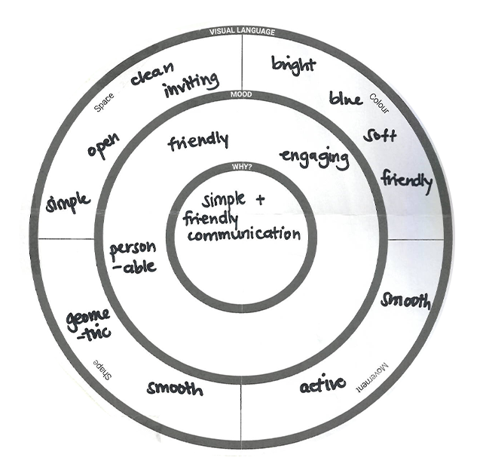

***Figure:*** *Design Inception*

**Mood:** Friendly, Engaging, Personable

**Space:** Simple, Open, Clean, Inviting

**Shape:** Geometric, Smooth

**Colour:** Bright, Blue, Soft, Friendly

**Movement:** Active, Smooth